Secret Code



In this project you will train the computer to understand secret code words.

You’ll use that to say commands to a spy to guide it around a town.



This project worksheet is licensed under a Creative Commons Attribution Non-Commercial Share-Alike License

http://creativecommons.org/licenses/by-nc-sa/4.0/

This project requires a **microphone**. If you don’t have a computer with a microphone, you might prefer to try a different worksheet.

1. Go to <https://machinelearningforkids.co.uk/scratch3/>

The next few steps only work with **Google Chrome**.

If you don’t have access to Google Chrome, skip to **step 7** and start from there.

1. Load the **Speech to Text** extension  
   *Click on the* ***Extensions (plus)*** *button in the bottom left, and then choose* ***Speech to Text*** *from the list.*   
   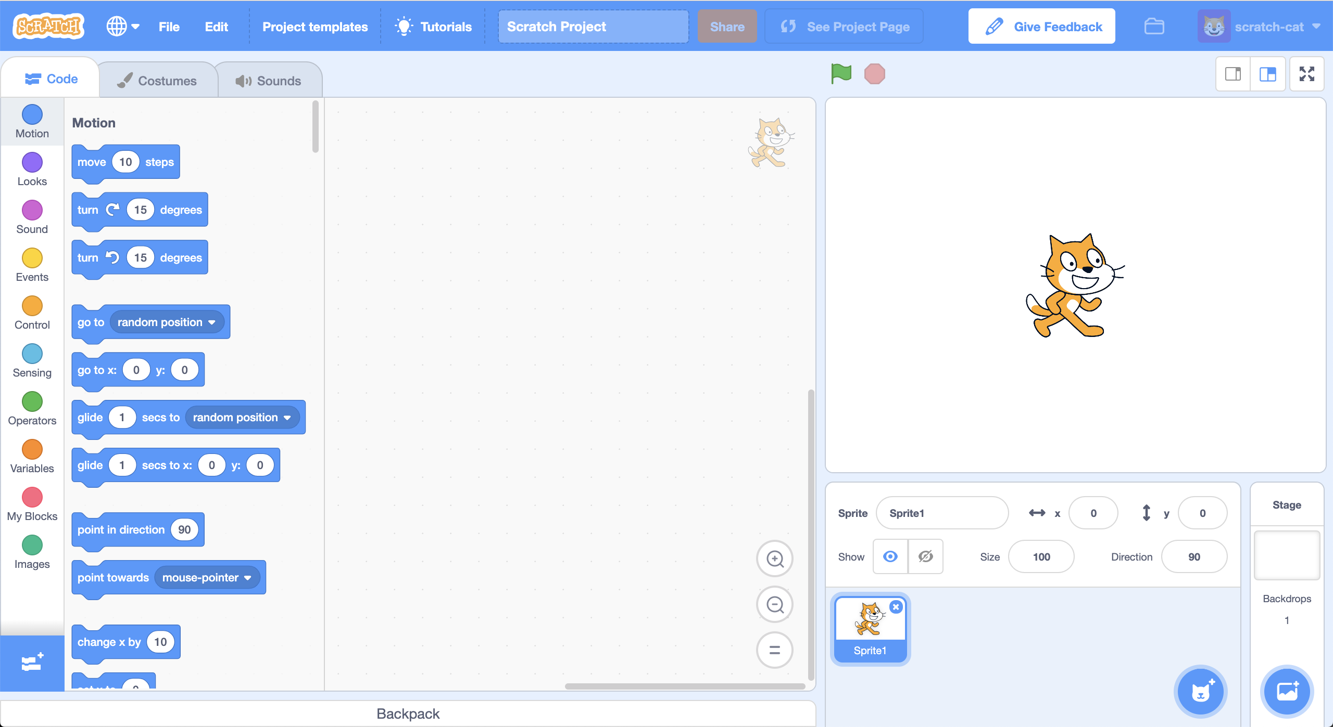
2. Load the **Secret Code** template  
   *Click on the* ***Project templates*** *menu at the top and then choose the* ***Secret Code*** *project.*  
   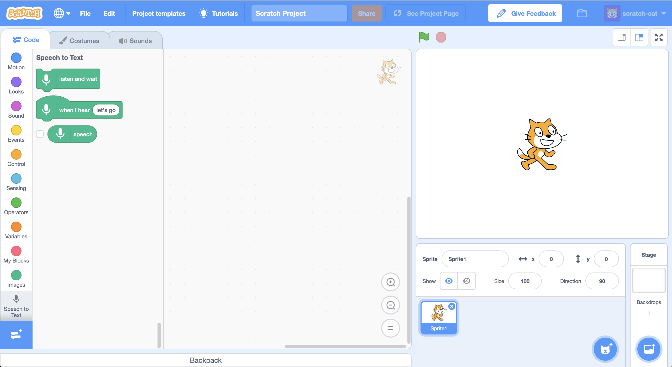
3. Add speech recognition to the script  
   *Find the* ***When Green Flag clicked*** *script and add a* ***listen and wait*** *block from Speech to Text*  
   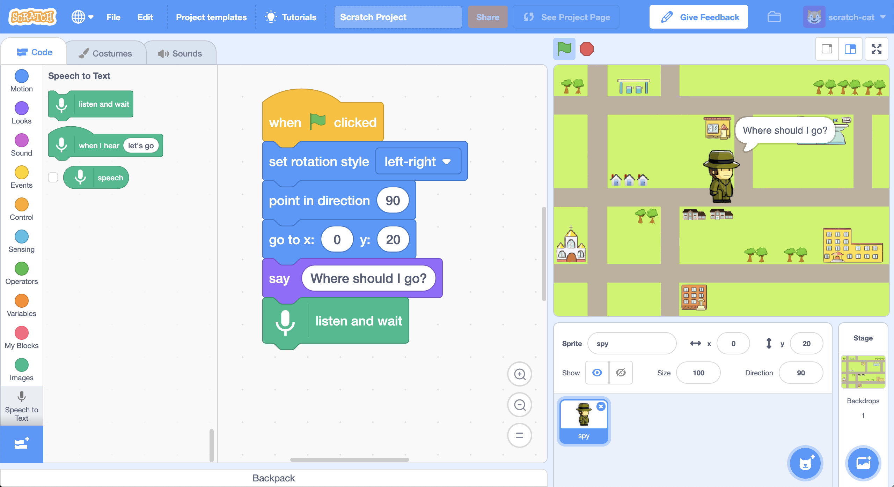
4. Add the following scripts.  
   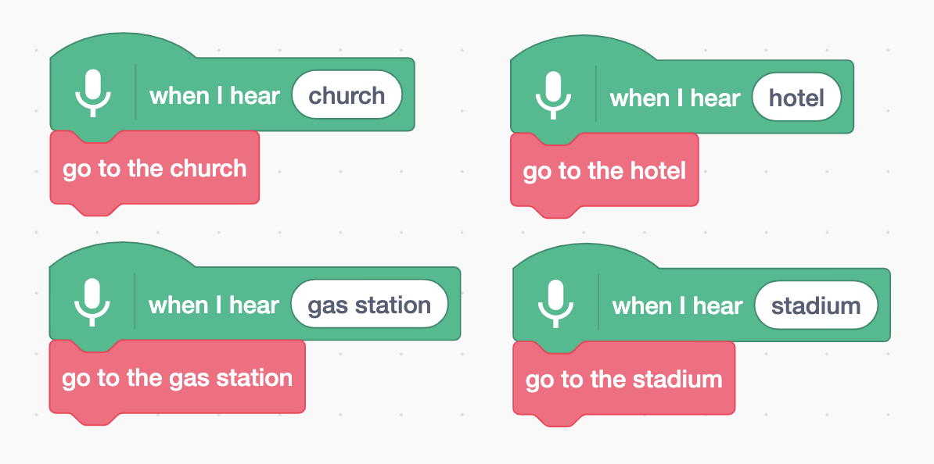
5. Click on the **Green Flag** and give it a try  
   *Say “church” or “hotel” or “gas station” or “stadium”.   
   The spy should go to the location that you say.*

**What have you done so far?**

You’ve used **speech recognition** to control the spy in Scratch. You’ve used a machine learning model that has already been trained for you. This is a general machine learning model that has been trained to recognize English dictionary words.

Next, you’ll train a machine learning model yourself to see how it is done.

For the next part of the project, you’ll train a machine learning model to recognise four new words. You’ll invent four new secret code words, that aren’t in the English dictionary. Once you’ve created your secret code words, you’ll train your spy to be able to recognize them. Then you will update your script so you can tell the spy where to go. The spy will understand you, but no one else will know what you mean!

1. Invent your secret code words!  
   *You need four words – a new secret code word for each of the four places in the spy project (church, stadium, gas station, hotel).   
   Invent new words that wouldn’t show up in an English dictionary. They can be random noises as long as you can repeat them in the same way every time and will be recognisably different from each other.   
   If you don’t want to make weird noises with your voice, that’s okay - find other ways to make noises. You can click your fingers, clap your hands, squeeze a squeaky toy or do anything else you can think of!*
2. Go to <https://machinelearningforkids.co.uk/>
3. Click on “**Log In**”
4. Click on “**Try it now**”
5. Click on “**Projects**” on the top menu bar
6. Click the **“+ Add a new project**” button.
7. Name your project “Secret Code” and set it to learn how to recognise “**sounds**”. Click the “**Create**” button  
   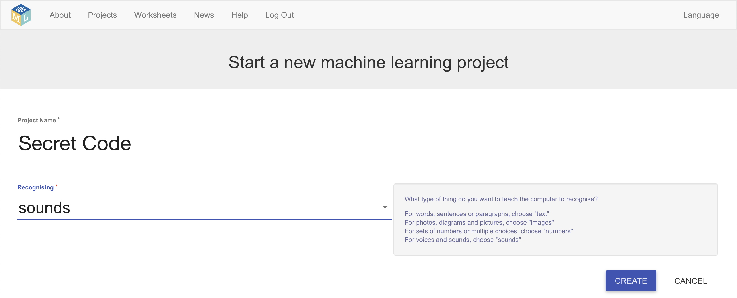
8. You should now see “**Secret Code**” in the list of your projects.   
   Click on it.
9. Click on the **Train** button to start collecting examples.
10. Click on the **Add example** button in the **background noise** bucket  
    *Recording background noise will help your machine learning model to tell the difference between the sounds you will train it to recognize, and the background noise where you are.*  
    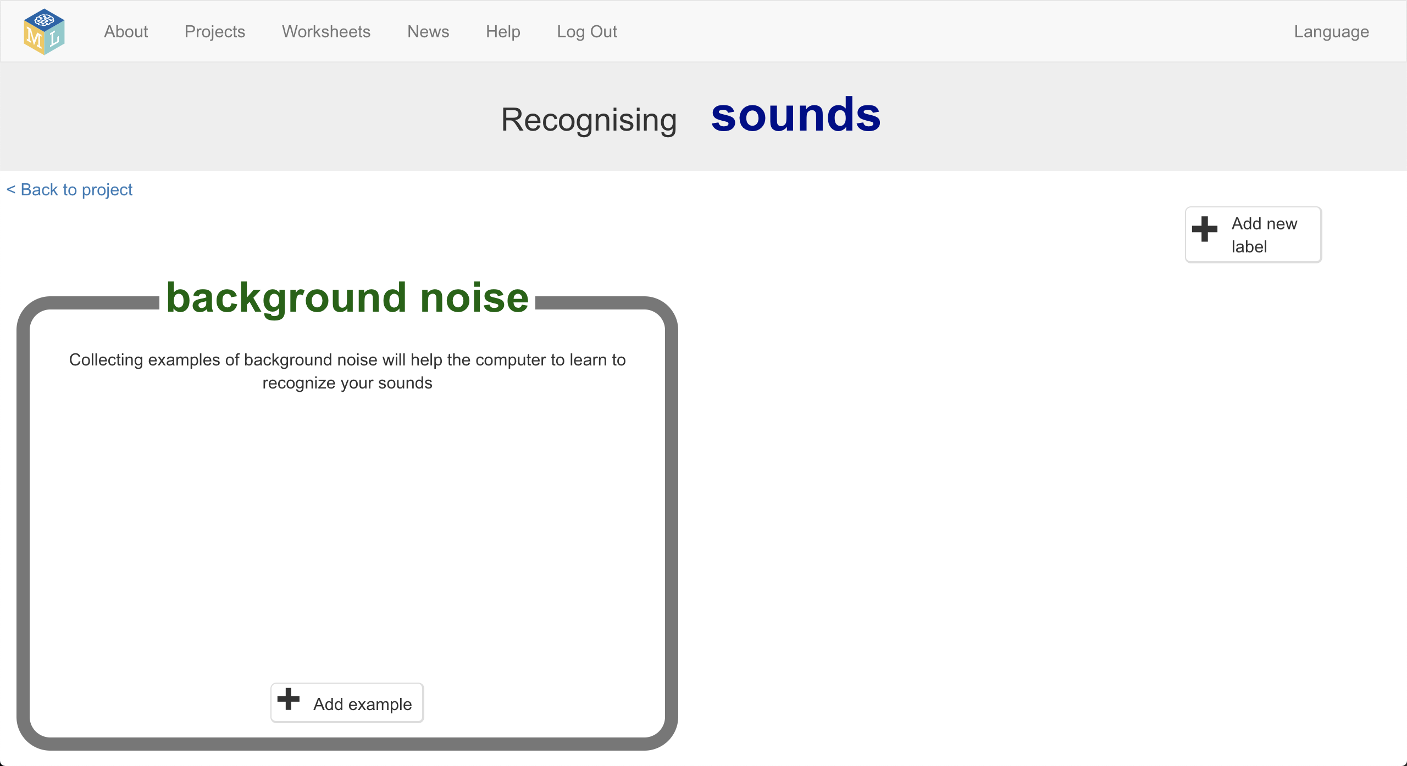
11. Click the **microphone** to record 2 seconds of background noise  
    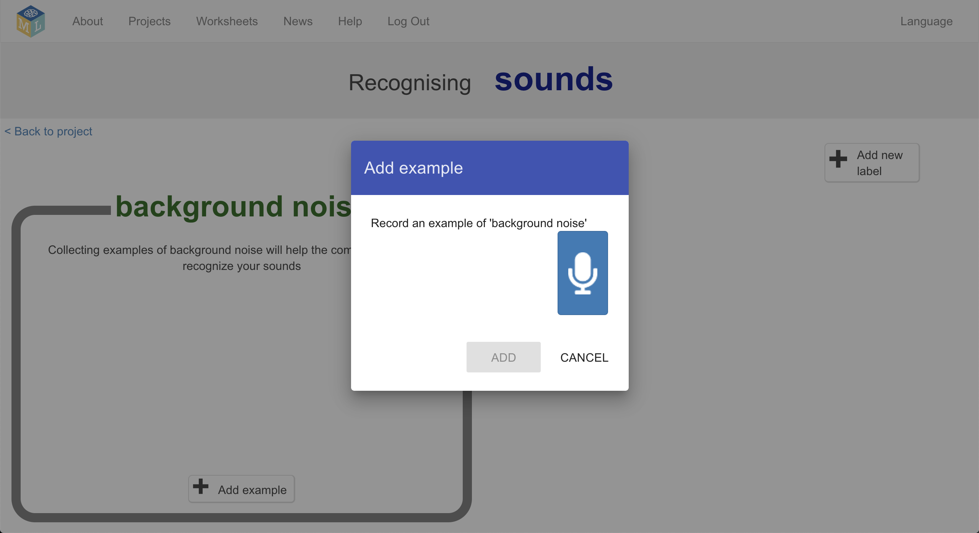
12. Click the **Add** button to save your recording   
    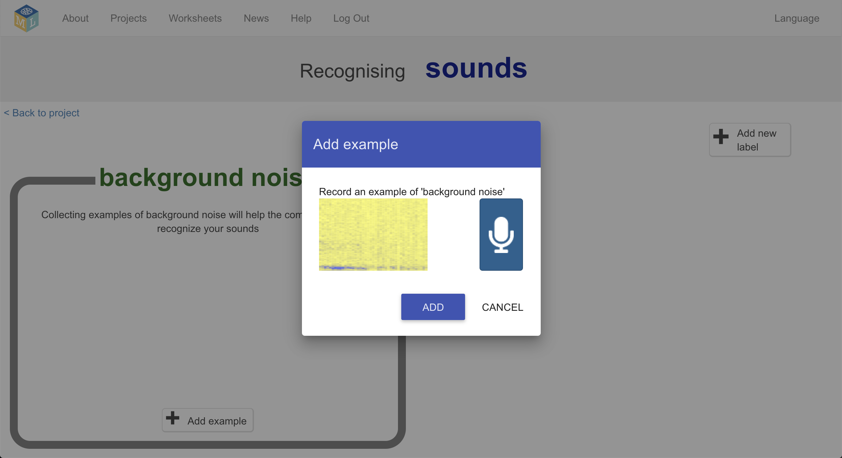
13. Repeat that until you have **at least 8** examples of background noise  
    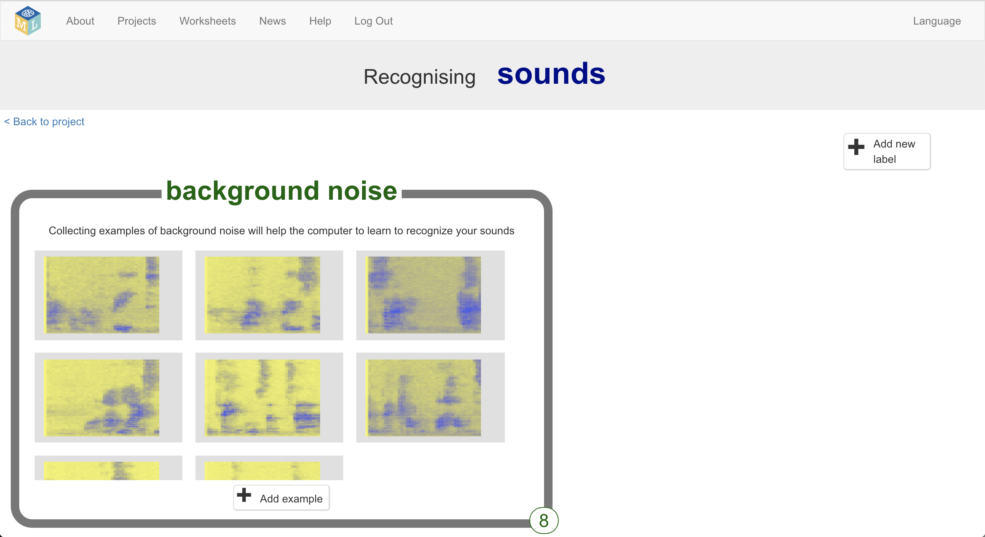
14. Use the **Add new label** button in the top right to create four new training buckets: “hotel”, “church”, “stadium”, “gas station”.   
    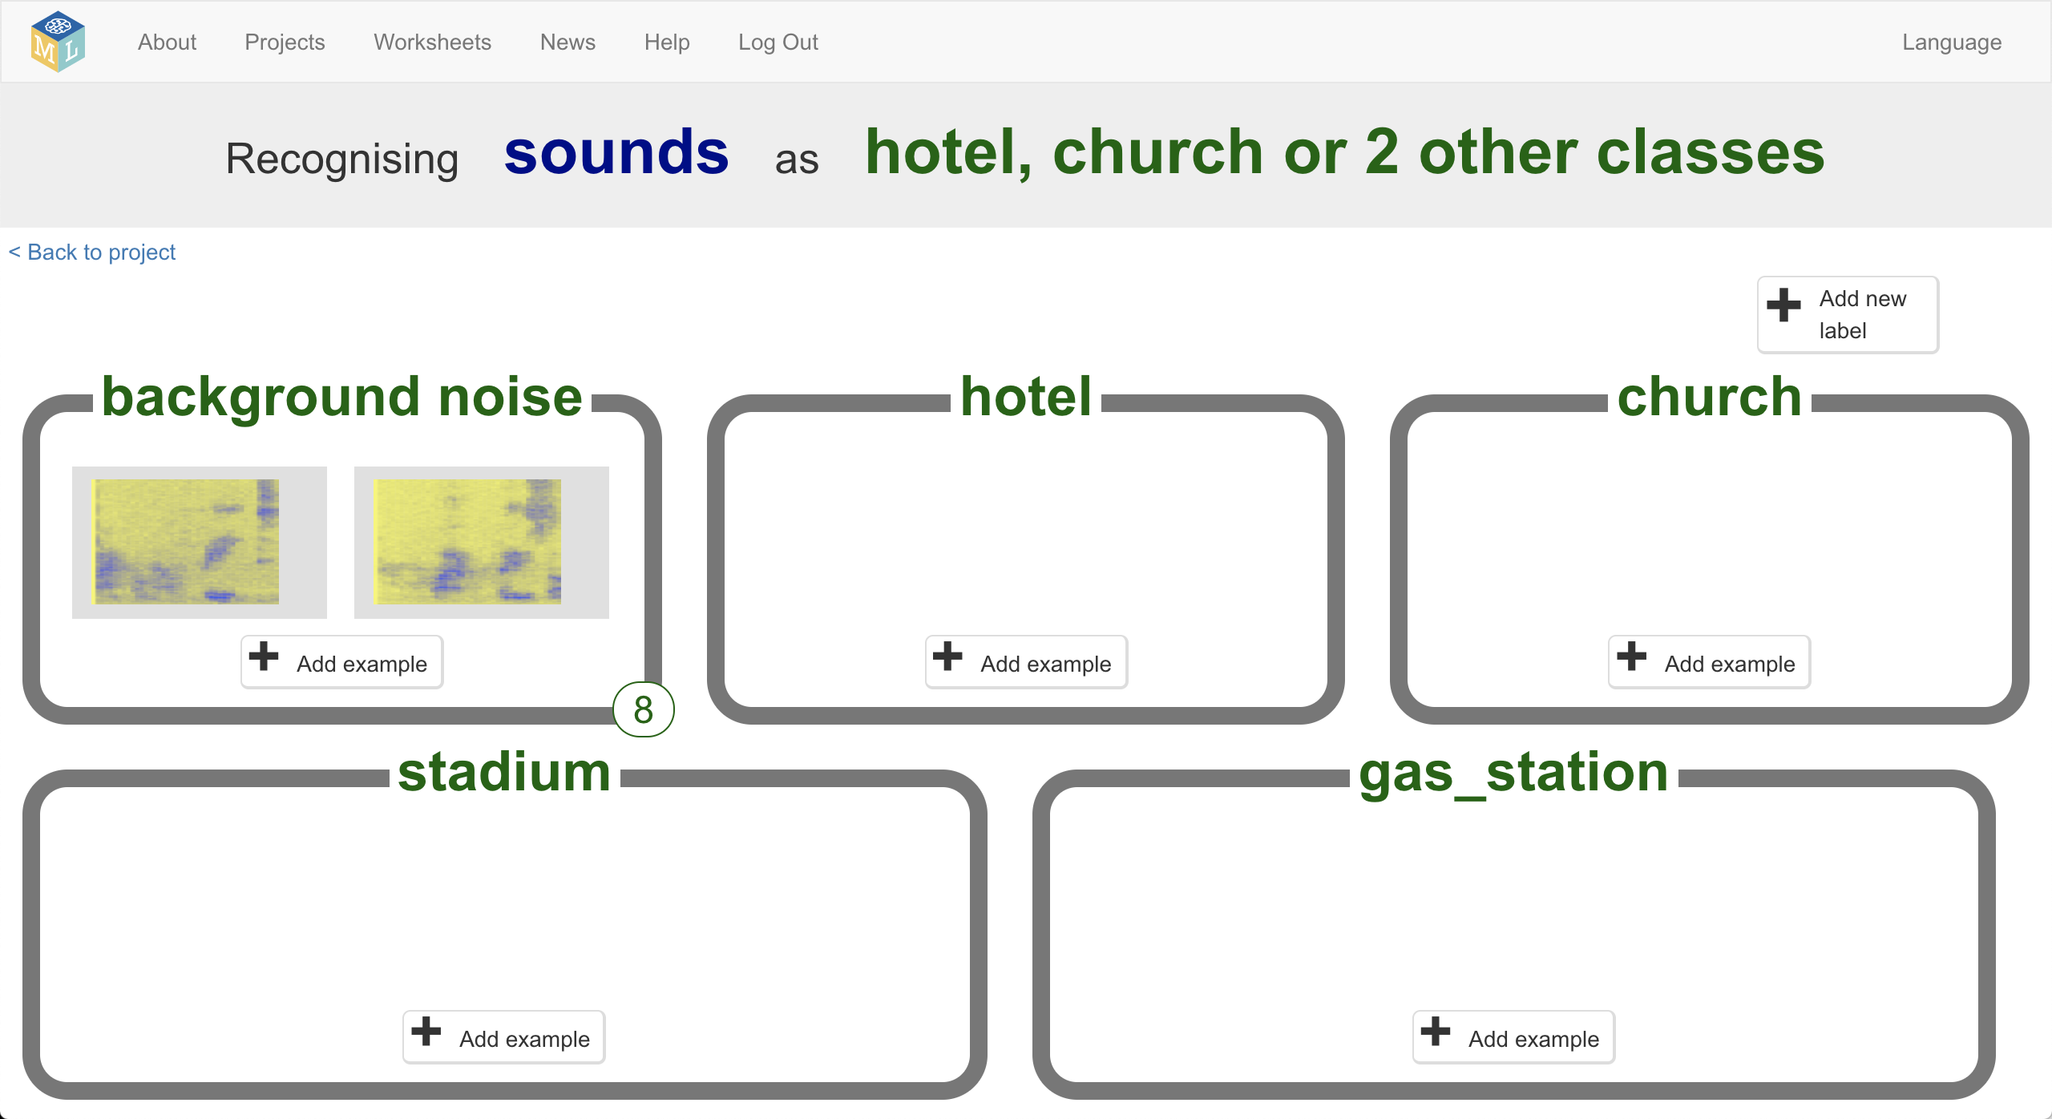
15. Click the **Add example** buttonin the **hotel** training bucket
16. Click on the microphone and record yourself saying your secret code word for “hotel”  
    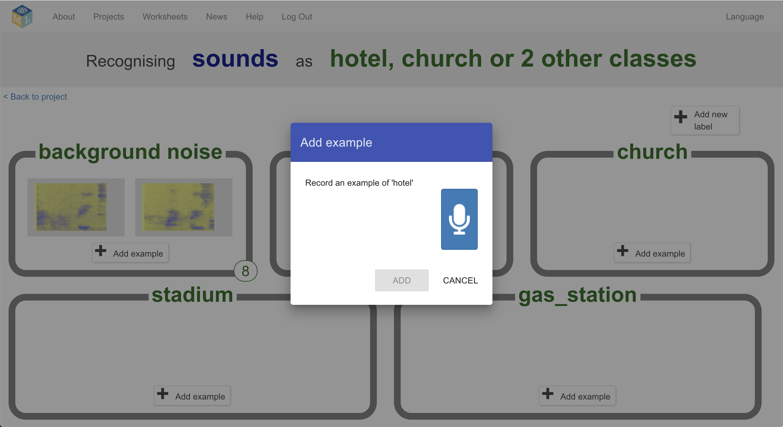
17. Click on the **Add** button to save the recording
18. Repeat until you’ve got **at least 8** examples of each of your four code words  
    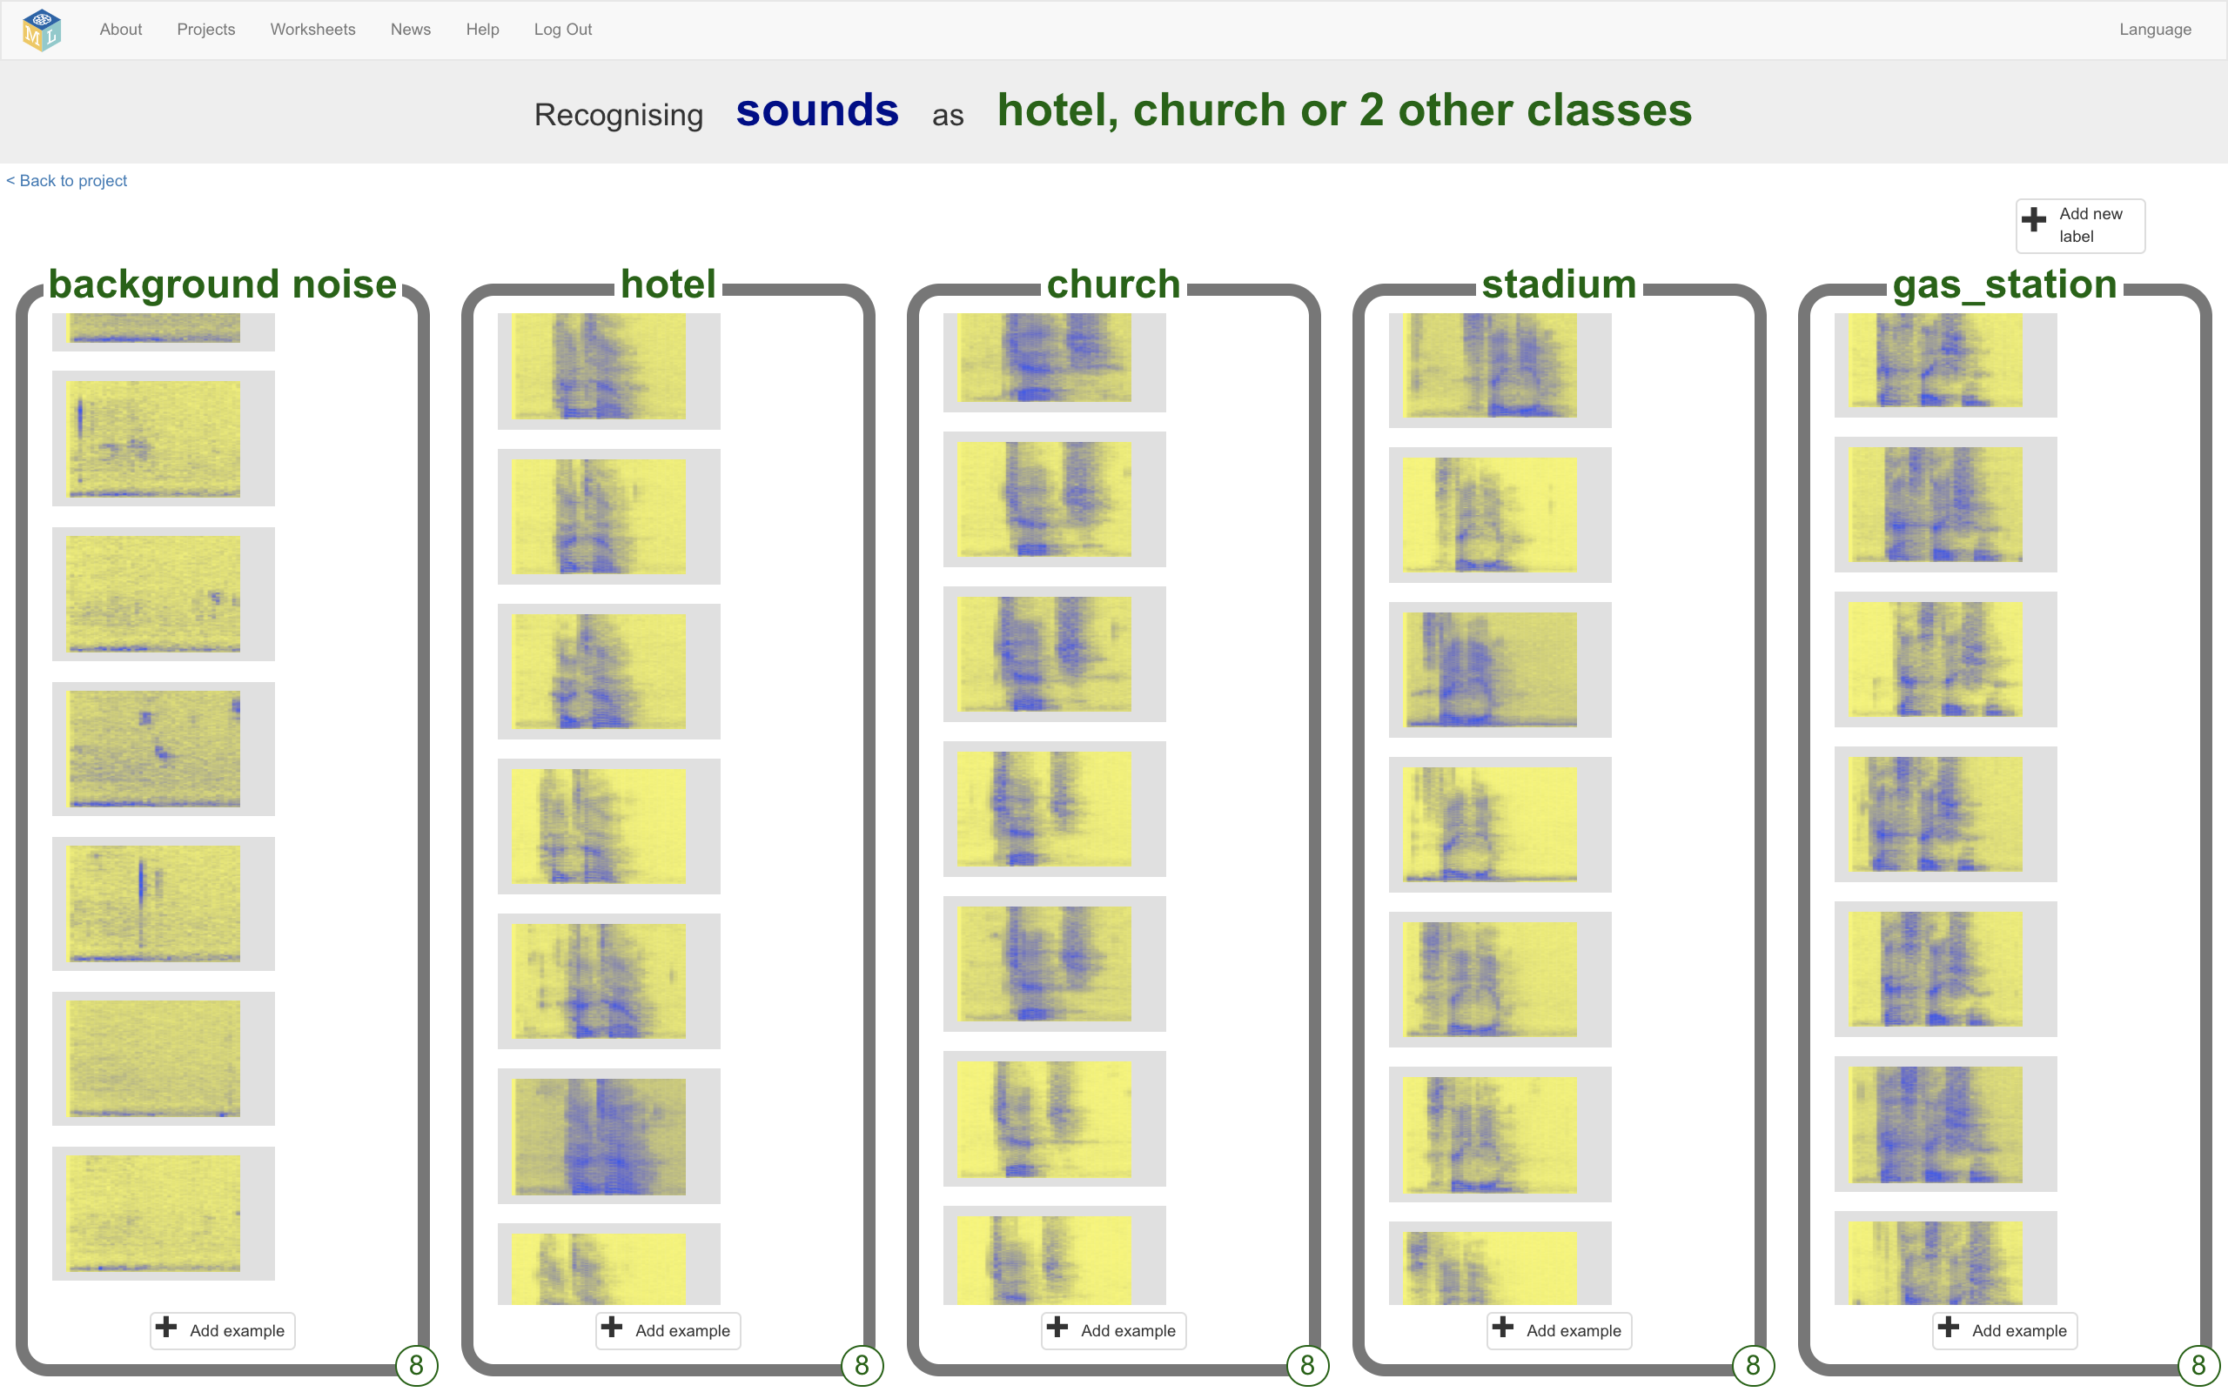
19. Click the “**Back to project**” link in the top left
20. Click the **Learn & Test** button
21. Click “**Train new machine learning model**”  
    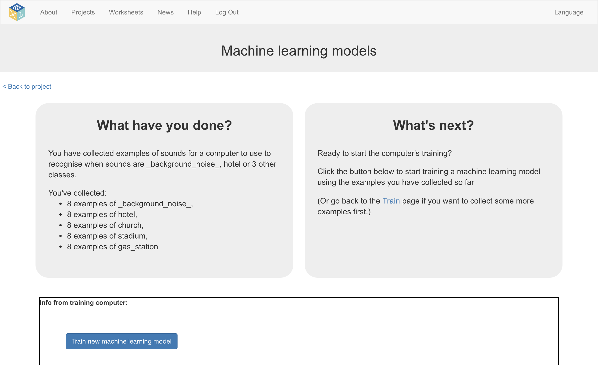
22. Once the training is finished, click the **Start listening** button to test your machine learning model  
    *Say one of your secret code words. If your machine learning model recognizes it, it will display what it thinks you said.*  
    
23. If you’re not happy with how the model is working, go back to the **Train** page and add more examples to all the training buckets.
24. When you’re happy with your machine learning model, click on the **Make** button  
    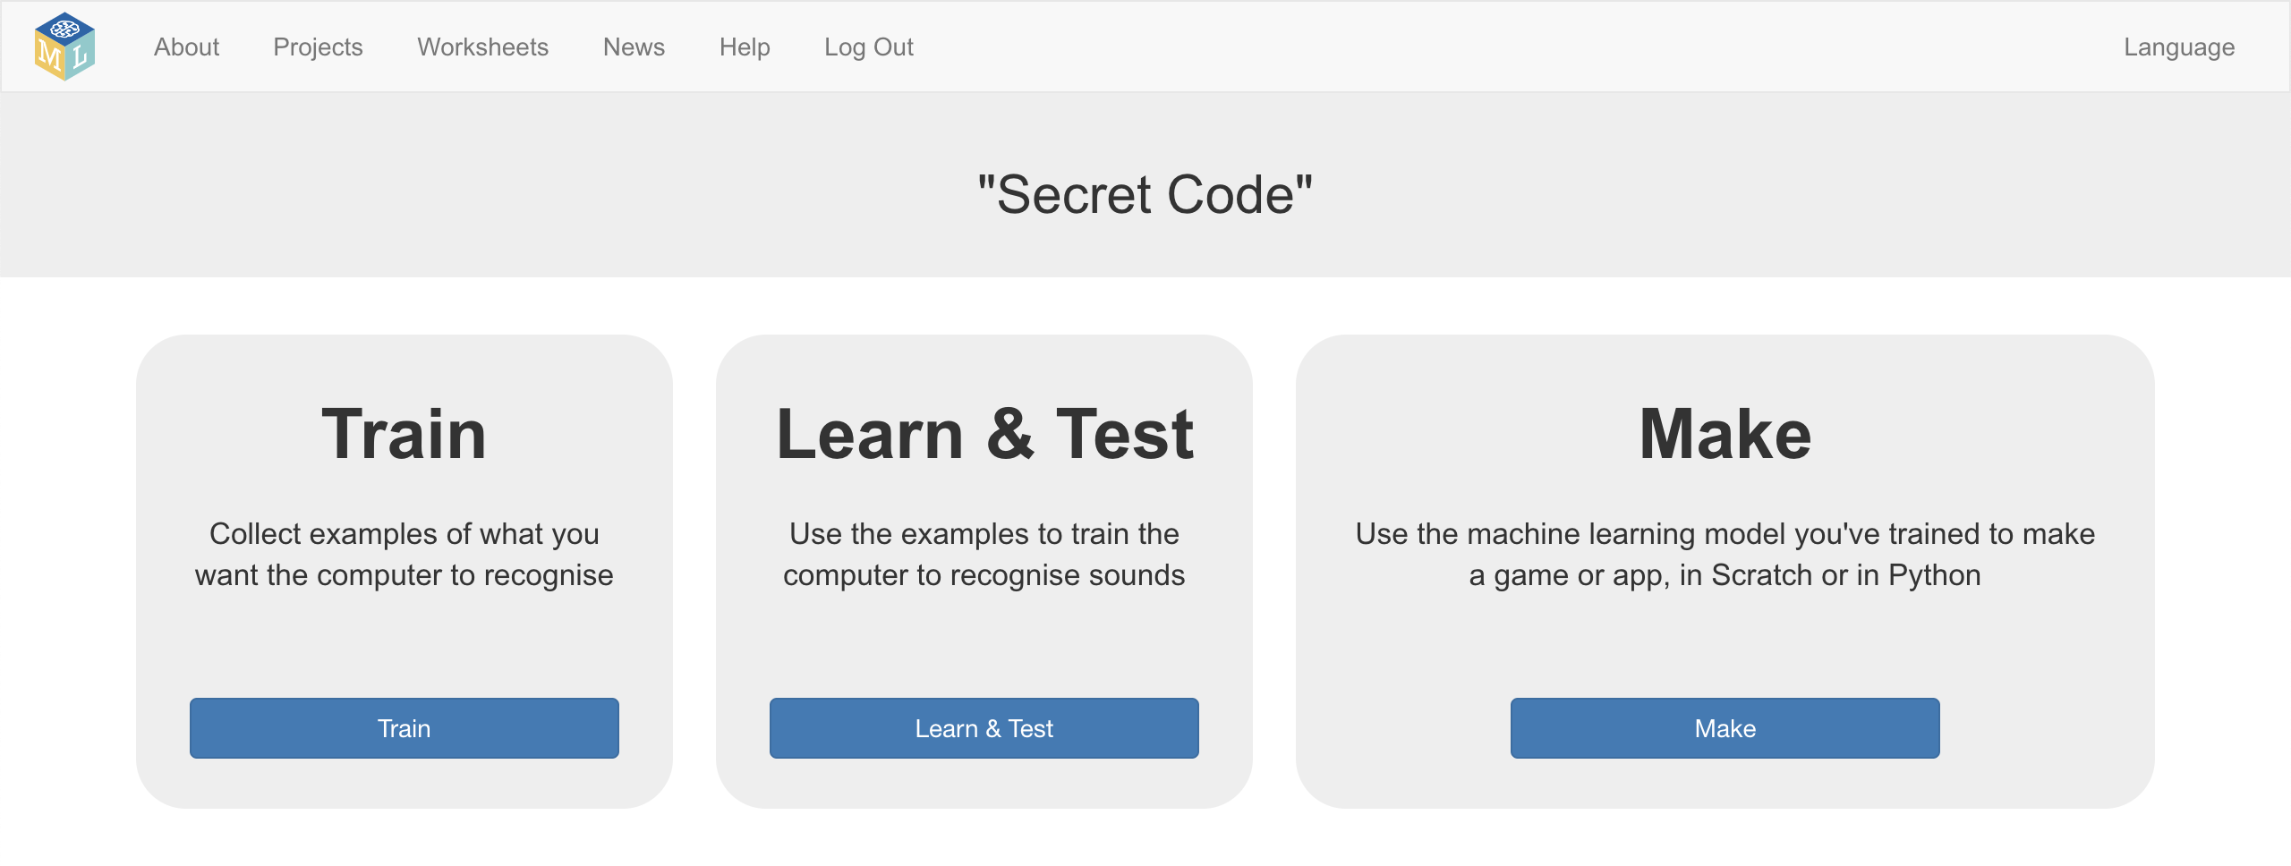
25. Click on the **Scratch 3** button and then click **Open in Scratch 3**
26. Click on the **Project templates** button at the top of the screen and open the “Secret Code” project template again
27. Add the following blocks to the **When Green Flag clicked** script  
    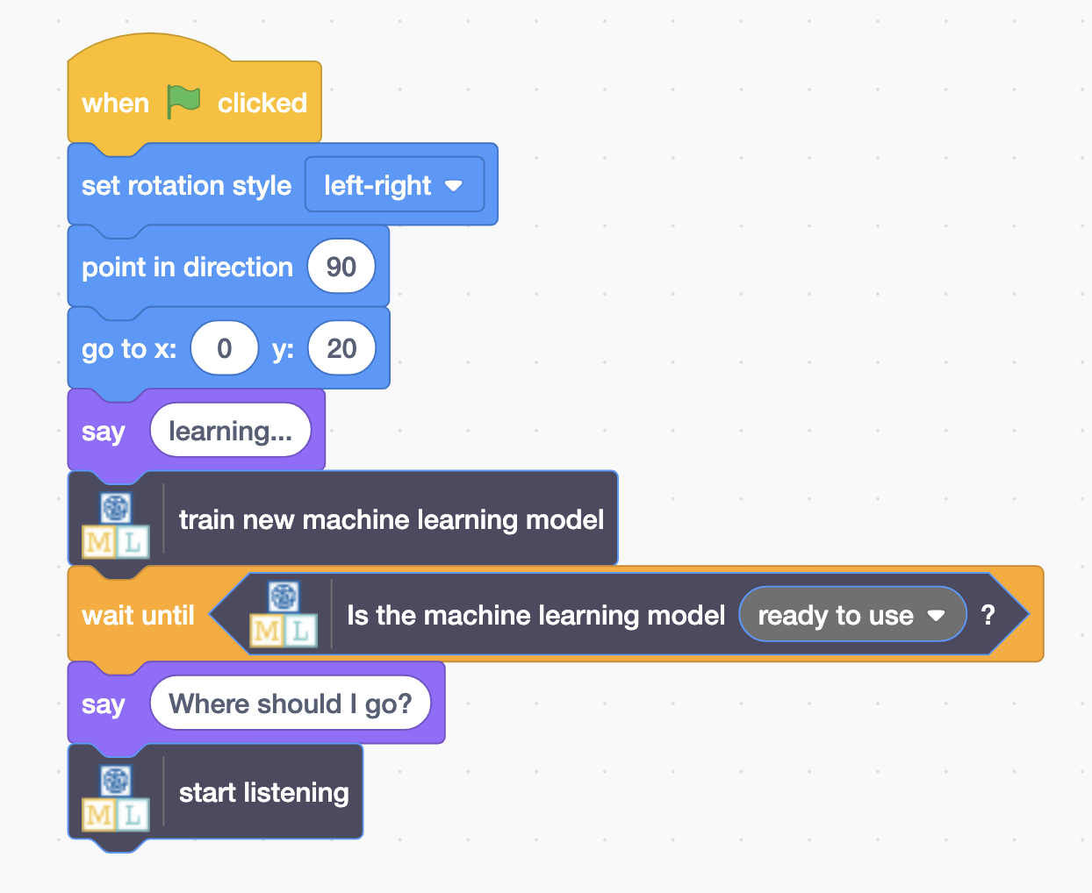
28. Add the following scripts  
    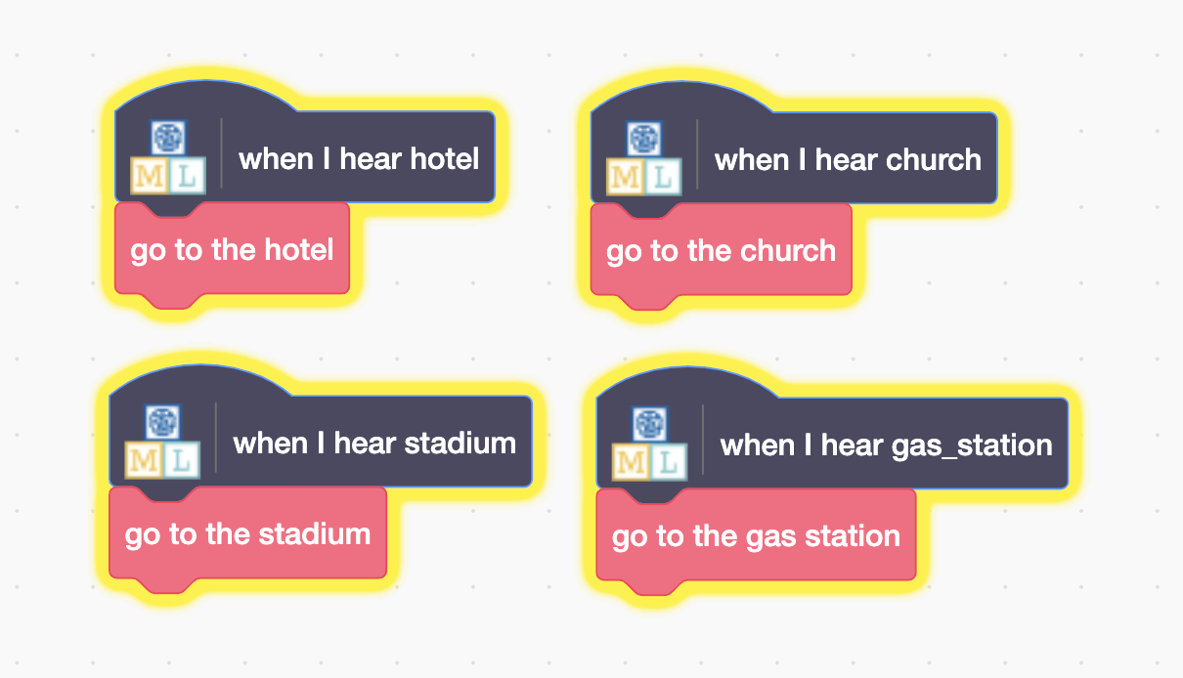
29. It’s time to test! Click the **Green Flag***After your spy has finished learning, it will ask “Where should I go?”.   
    Use your secret code words to guide the spy around the town.*

**What have you done?**

You’ve trained your own machine learning model to do speech recognition. You used that to control a character in Scratch.

Unlike the pre-trained model you used at first, which has been trained to recognize tens of thousands of words, you’ve only trained it to recognize four different words. But the principle is the same.

Can you think of an example of a system like this you’ve seen used before? For example, some cars use speech recognition systems that have been trained to recognize the different commands you can give to the in-car computer. What other examples have you used?

**Ideas and Extensions**

Now that you’ve finished, why not give one of these ideas a try?

Or come up with one of your own?

**Try a different voice**

Ask a friend to test your spy. Does it understand them?

If it has trouble with their voice, ask them to add some training examples of their voice to your training buckets and then try again.

How much training does it need for your machine learning model to be able to work with a variety of voices?